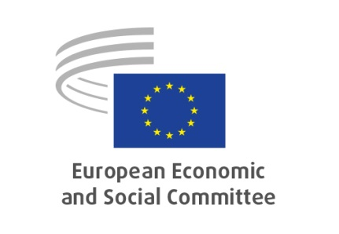
EN
INT/998

NOTICE OF MEETING
SECTION FOR THE SINGLE MARKET, PRODUCTION AND CONSUMPTION
Study Group on Strategic Foresight Report 2022

Date | 13/01/2023, Hearing 10.00-13.00, study group meeting 14.30-17.30
Venue | Rue Belliard/Belliardstraat 99 – 1040 Bruxelles/Brussel
Room | VMA3 - Interactio hybrid meeting
President | Sandra PARTHIE (DE – I)
Meeting No | 2
Document date | 15/12/2022

10.00-13.00: Hearing

Programme of the Hearing will be distributed separately.

14.30-17.30: Study group meeting

Adoption of the draft agenda

- Exchange of views with the European Commission representative

Discussion of the Preliminary draft opinion on Communication from the Commission to the European Parliament and the Council – 2022 Strategic Foresight Report – Twinning the green and digital transitions in the new geopolitical context

COM(2022) 289 final

EESC-2022-04981-00-00-APA-TRA

Rapporteur: Angelo PAGLIARA

Any other business

Date of the next meeting.

Working languages | EN/FR/IT
Interpreting requested from | EN/FR/IT
into | EN/FR/IT
_____________

N.B.: This meeting is held in hybrid form.
Participants who plan to attend this meeting remotely must give the secretariat seven days' notice.
Members and advisors attending the meeting in person are asked to sign the attendance list in order to ensure that their meeting expenses are refunded.
Members unable to attend the meeting are asked to give advance notice to their group secretariat so that interpreters do not attend unnecessarily.
Recorded meeting - see Decision No 206/17A. Privacy statement.

